**EXERCISE -** 7

**0/1 KNAPSACK PROBLEM**

**Aim:** Write a java program to solve 0/1 Knapsack problem

**File name:** Knapsack.java

**Program:**

**import java.util.Scanner;**

**class Knapsack {**

**public static void main(String[] args) {**

**Scanner sc=new Scanner(System.in);**

**int object,m;**

**System.out.println("Enter the Total Objects");**

**object=sc.nextInt();**

**int weight[]=new int[object];**

**int profit[]=new int[object];**

**for(int i=0;i<object;i++) {**

**System.out.println("Enter the Profit");**

**profit[i]=sc.nextInt();**

**System.out.println("Enter the weight");**

**weight[i]=sc.nextInt();**

**}**

**System.out.println("Enter the Knapsack capacity");**

**m=sc.nextInt();**

**double p_w[]=new double[object];**

**for(int i=0;i<object;i++){**

**p_w[i]=(double)profit[i]/(double)weight[i];**

**}**

**System.out.println("\n-------------------");**

**System.out.println("-----Data-Set------");**

**System.out.print("-------------------");**

**System.out.println("");**

**System.out.print("Objects");**

**for(int i=1;i<=object;i++){**

**System.out.print(i+" ");**

**}**

**System.out.println();**

**System.out.print("Profit ");**

**for(int i=0;i<object;i++){**

**System.out.print(profit[i]+" ");**

**}**

**System.out.println();**

**System.out.print("Weight ");**

**for(int i=0;i<object;i++){**

**System.out.print(weight[i]+" ");**

**}**

**System.out.println();**

**System.out.print("P/W ");**

**for(int i=0;i<object;i++){**

**System.out.print(p_w[i]+" ");**

**}**

**for(int i=0;i<object-1;i++){**

**for(int j=i+1;j<object;j++){**

**if(p_w[i]<p_w[j]){**

**double temp=p_w[j];**

**p_w[j]=p_w[i];**

**p_w[i]=temp;**

**int temp1=profit[j];**

**profit[j]=profit[i];**

**profit[i]=temp1;**

**int temp2=weight[j];**

**weight[j]=weight[i];**

**weight[i]=temp2;**

**}**

**}**

**}**

**System.out.println("");**

**System.out.println("-------------------\n--After Arranging–\n-------------------");**

**System.out.println("");**

**System.out.print("Objects");**

**for(int i=1;i<=object;i++){**

**System.out.print(i+" ");**

**}**

**System.out.println();**

**System.out.print("Profit ");**

**for(int i=0;i<object;i++){**

**System.out.print(profit[i]+" ");**

**}**

**System.out.println();**

**System.out.print("Weight ");**

**for(int i=0;i<object;i++){**

**System.out.print(weight[i]+" ");**

**}**

**System.out.println();**

**System.out.print("P/W ");**

**for(int i=0;i<object;i++){**

**System.out.print(p_w[i]+" ");**

**}**

**int k=0;**

**double sum=0;**

**System.out.println();**

**while(m>0){**

**if(weight[k]<m){**

**sum+=1*profit[k];**

**m=m-weight[k];**

**}**

**else{**

**double x4=m*profit[k],x5=weight[k],x6=x4/x5;**

**sum=sum+x6;**

**m=0;**

**}**

**k++;**

**}**

**System.out.println("Final Profit is="+sum);**

**sc.close();}}**

**Output:**

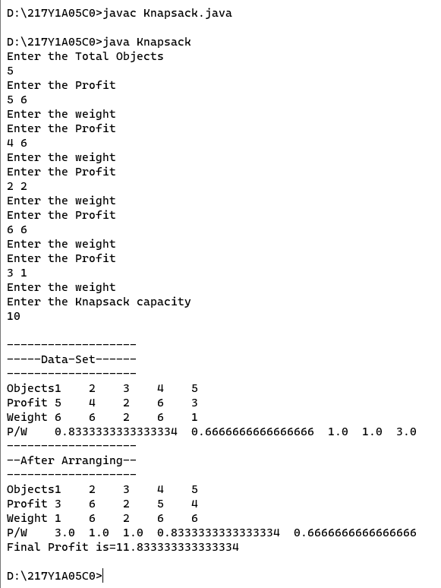

**Aim:** Write a java program to demonstrate Exception.

**File name:** Exception.java

**Program:**

**public class Exception {**

**public static void main(String[] args) {**

**try {**

**int data = 100 / 0;**

**} catch (ArithmeticException e) {**

**System.out.println("An exception has been caught: " + e.getMessage());**

**} finally {**

**System.out.println("This code will always be executed");**

**}**

**}**

**}**

**Output:**

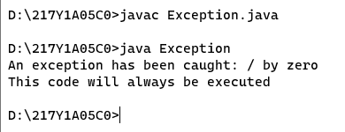

**Aim:** Write a java program to demonstrate **throws** keyword

**File name:** ThrowDemo.java

**Program:**

**class ThrowDemo {**

**static void divide(int a, int b) throws ArithmeticException {**

**if (b == 0) {**

**throw new ArithmeticException("Division by zero!");**

**} else {**

**System.out.println(a / b);**

**}**

**}**

**public static void main(String[] args) {**

**try {**

**divide(10, 0);**

**} catch (ArithmeticException e) {**

**System.out.println("Exception caught: " + e.getMessage());**

**}**

**}**

**}**

**Output:**

